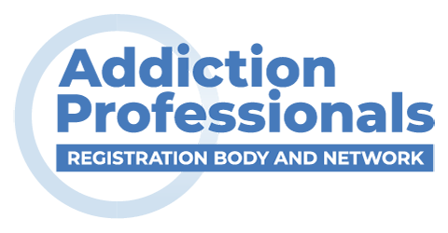
Addiction Professionals
Drug & Alcohol Professional
Re-certification Application Form

Please click within the blank box to enter your text or print out and manually complete.

Name of applicant:

Contact details:

Are you a full individual member of FDAP? Y / N

If yes, please give membership number here:

If no, are you an associate member (covered by an affiliated agency)?

If yes, please specify here:

[NB - this scheme is open only to full and associate members]

Compulsory units

Using the table of evidence below, please specify the type/s of evidence you are submitting re. your competence in the 9 compulsory units' (see 'notes' below for an example of how to complete this).

Unit | Evidence Details
SCDHSC 0031
SCDHSC 0032
SCDHSC 0033
SCDHSC 0035
GEN 36
SCDHSC 0233
SCDHSC 3111
DANOS AB5.2014
DANOS AF2.2012/AF3.2014*

Optional unit
Using the table of evidence below, please identify the 'specialist’ optional unit in your application and specify the type/s of evidence you are submitting re. your competence in this.
Unit | Evidence Details

Addiction Professionals Drug & Alcohol Professional Re-certification Application Form Declaration

I attach copies of qualification certificates (endorsed by my line manager / supervisor) and , as applicable, a workplace assessment. I confirm that I have demonstrated my competence to my manager in relation to each of the above units. I attach a copy of the Workplace Assessment - Senior Manager Approval form, in support of any Workplace Assessment.

I have read and agree to abide by Addiction ProfessionalsClick or tap here to enter text. Code of Practice.

Signed:

Date:

Submitting your application

If you are applying direct to Addiction Professionals, the fee for Certification is £75 for three years - Bank details are Addiction Professionals Sort Code 60-83-01 Account number 20438021. Please use ‘ADAP Re-accreditation’ as reference when making a BACS payment.

If you are applying through an affiliated agency, please submit your application to your relevant representative. Do not send your application direct to Addiction Professionals.

Notes: Your application should include only evidence recognised by the PCAP.
An example of how the table of evidence should be completed is given below:

Unit | Evidence Details
SCDHSC 0031 | OU/Addiction Professionals award covering this unit
DANOS AB5.2014 | Workplace assessment & Brighton Uni Diploma in Substance Misuse Intervention Studies
DANOS AF2.2012/AF3.2014* | Workplace assessment only

You must supply copies of relevant qualification certificates in support of your application where relevant. These must be counter-signed by your line manager / supervisor, endorsing their validity. [“Professionally qualified” practitioners must let us have a validated copy of a UK practising certificate.]

Evidence of competence based on a workplace assessment should be provided using the appropriate 'Workplace Assessment Report' for the unit concerned and should be accompanied by a 'Workplace Assessment - Senior Manager Approval' form.

